**Database Model for Guvi Zen Class**

Students Table

* studentid (Primary Key, INT, AUTO_INCREMENT)
* name varchar(100)
* e-mail varchar(100)
* contact_Number integer
* mentor_Id integer > Mentors.id(FOREIGN KEY)

### Tasks Table

* taskid (Primary Key, INT, AUTO_INCREMENT)
* student_Id integer > Student.id (FOREIGN KEY)
* task-Id integer > Task.id
* status varchar(100)

### Mentors Table

* mentorid (Primary Key, INT, AUTO_INCREMENT)
* name varchar(100)
* expertise varchar(150)
* email varchar(100)

### Topics Table

* Topics_id (Primary Key, INT, AUTO_INCREMENT)
* topic_name varchar(100)
* date date
* mentor_id integer > Mentors.id (FOREIGN KEY)

### Codekata Table

* id (Primary Key, INT, AUTO_INCREMENT)
* student_Id integer > Student.id (FOREIGN KEY)
* task-Id integer > Task.id (FOREIGN KEY)
* status varchar(100)

### Company Drives Table

* mockinterviewid (Primary Key, INT, AUTO_INCREMENT)
* student_id integer > Student.id (FOREIGN KEY)
* mentor_id integer > Mentors.id (FOREIGN KEY)
* company_name varchar(200)
* date date
* role varchar(100)

DB DESIGNER:

Student {

id integer pk increments unique

name varchar(100)

e-mail varchar(100)

contact_Number integer

mentor_Id integer > Mentors.id

}

Codekata {

id integer pk increments unique

student_Id integer > Student.id

task-Id integer > Task.id

status varchar(100)

}

Attendance {

id integer pk increments unique

student_id integer > Student.id

date integer

status varchar(100)

}

Topics {

id integer pk increments unique

topic_name varchar(100)

date date

mentor_id integer > Mentors.id

}

Task {

id integer pk increments unique

task_name varchar(100)

description varchar(500)

due_date date

}

Company_drives {

id integer pk increments unique

student_id integer > Student.id

mentor_id integer > Mentors.id

company_name varchar(200)

date date

role varchar(100)

}

Mentors {

id integer pk increments unique

name varchar(100)

expertise varchar(150)

email varchar(100)

}

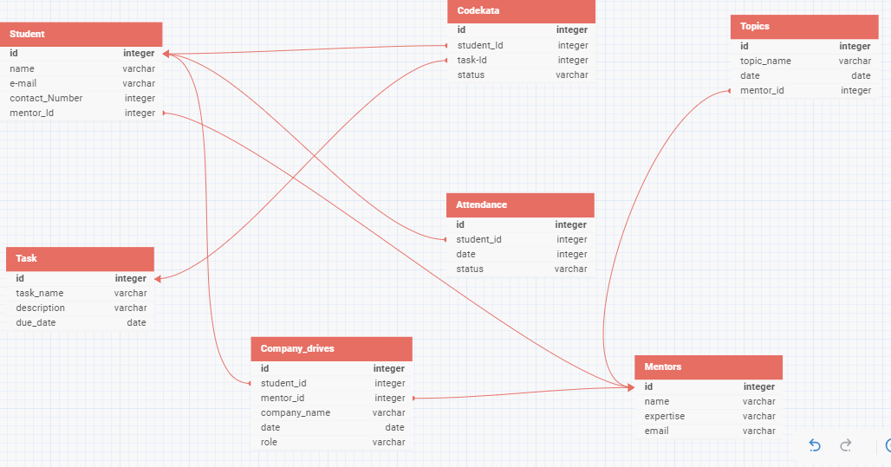

ZEN DB MODEL